**Lab - 3**

**Lab Network Perimeter Security**

**CSC-7303 - 11811 - Network Defense - 202501 - 001**

**Name: Unnati Patel – A00327586**

**Submitted to: Prof.  Maryam Ahmed**

**Task 1: Network-Based Firewall with OPNSense  
 Setup OPNSense Firewall**

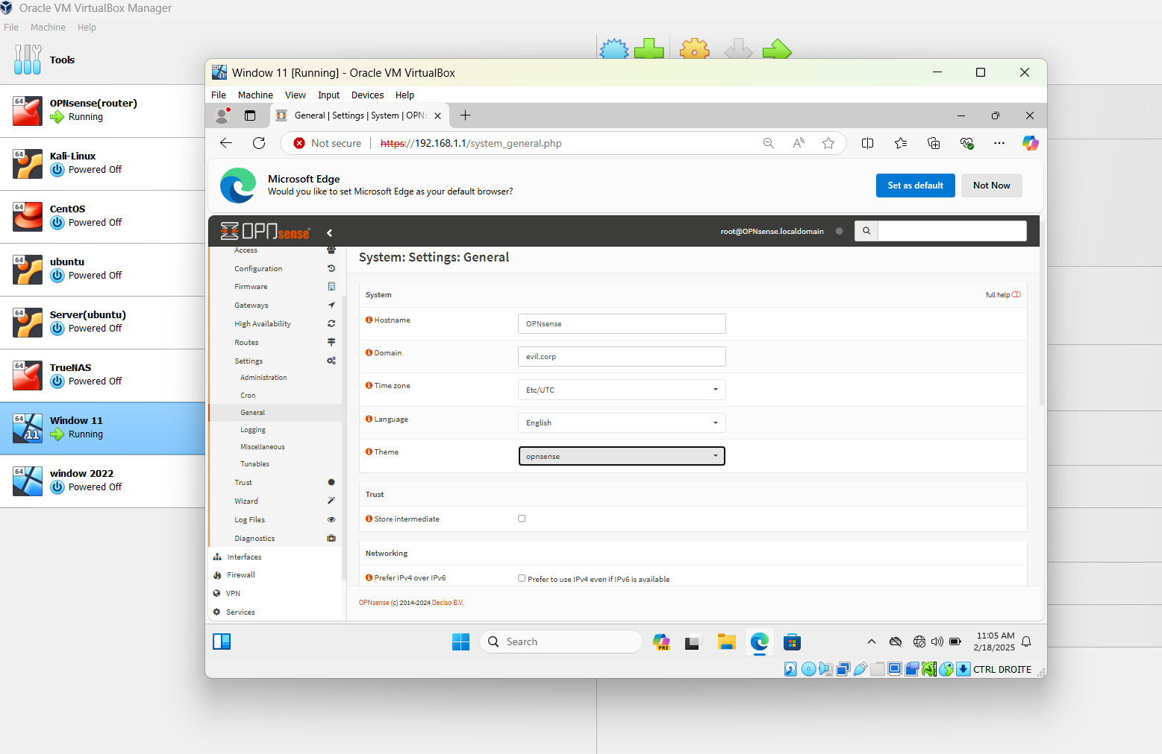

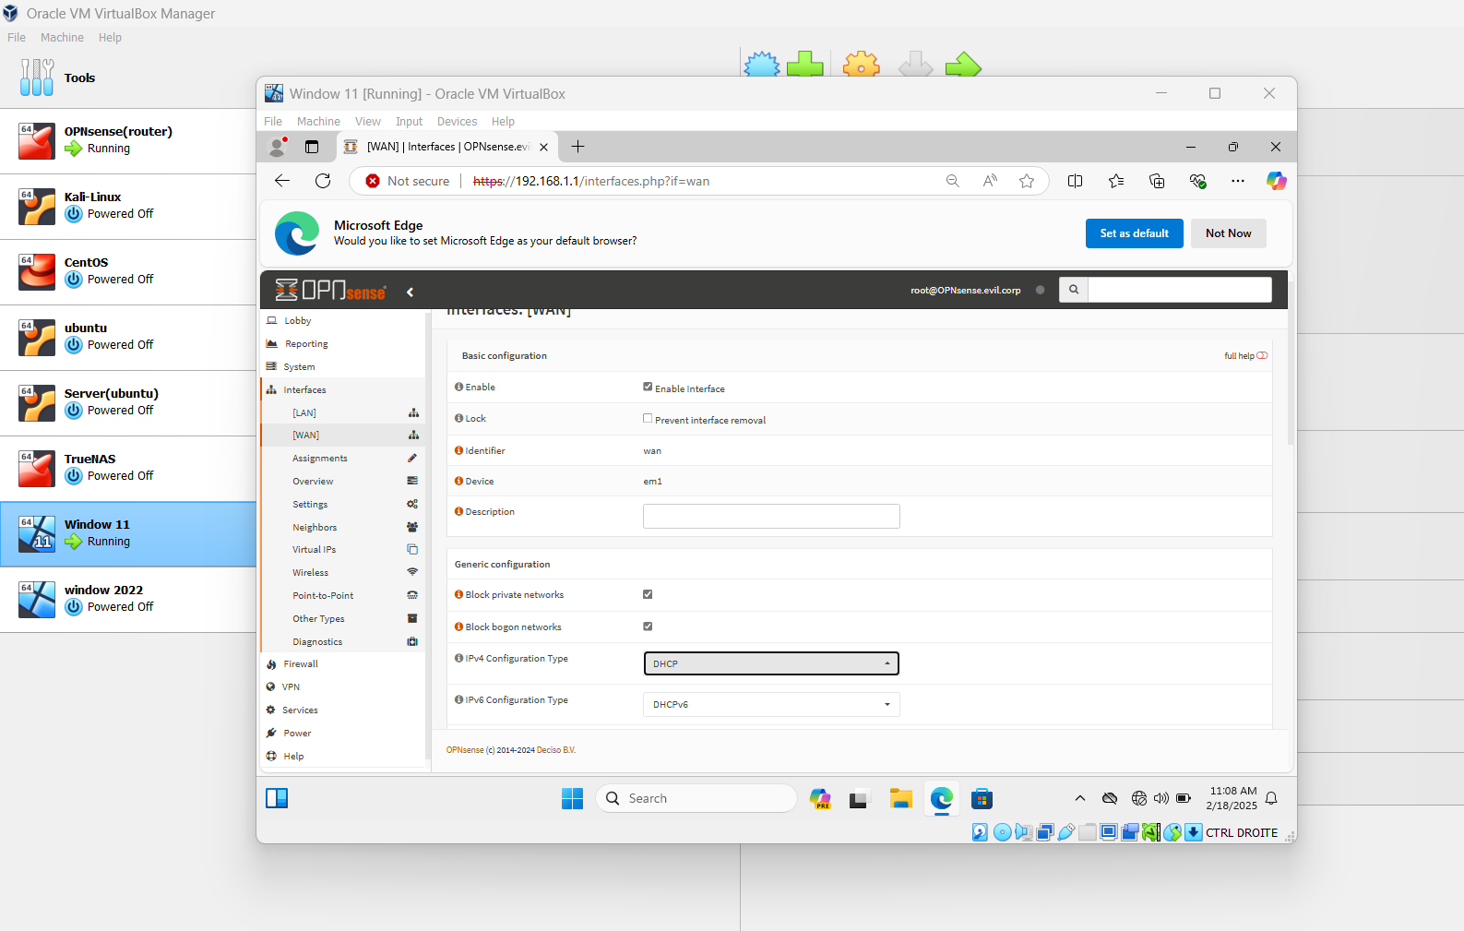

**Create an Alias for Blocked Websites**

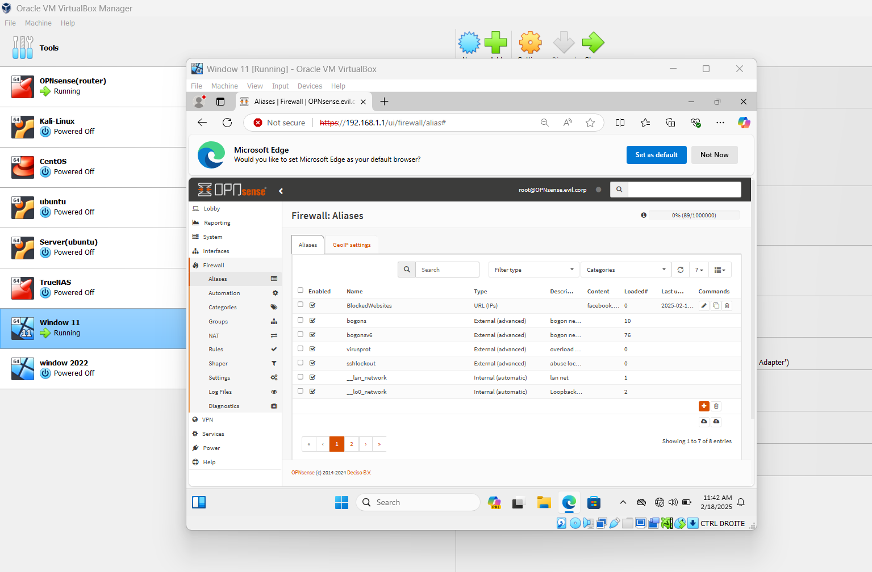

**Block Insecure Ports**

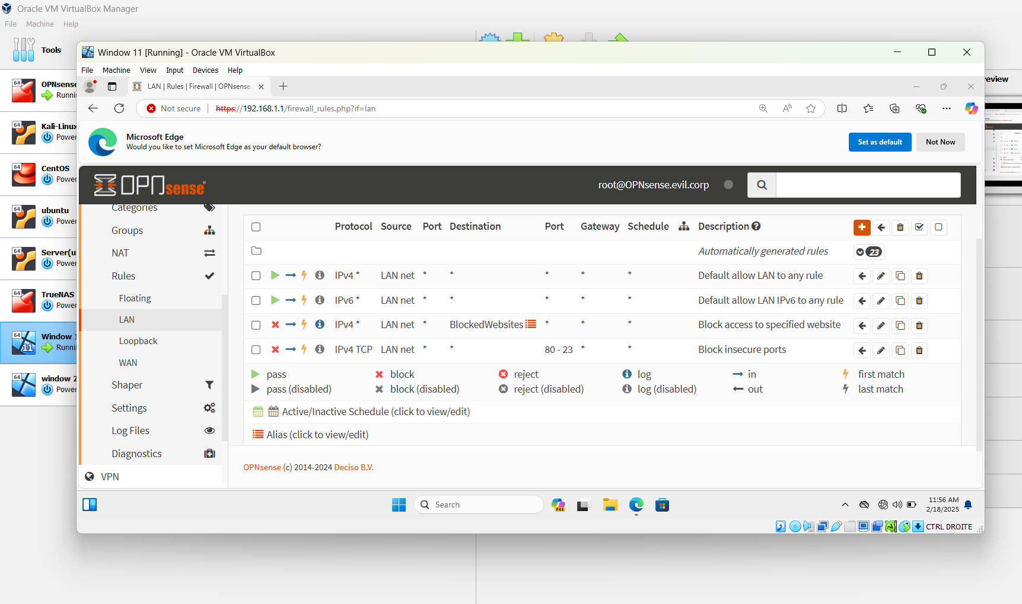

**Task 2: Host-Based Firewall with Windows Firewall**

1. **Configure Windows Firewall on Windows 11 Workstation**

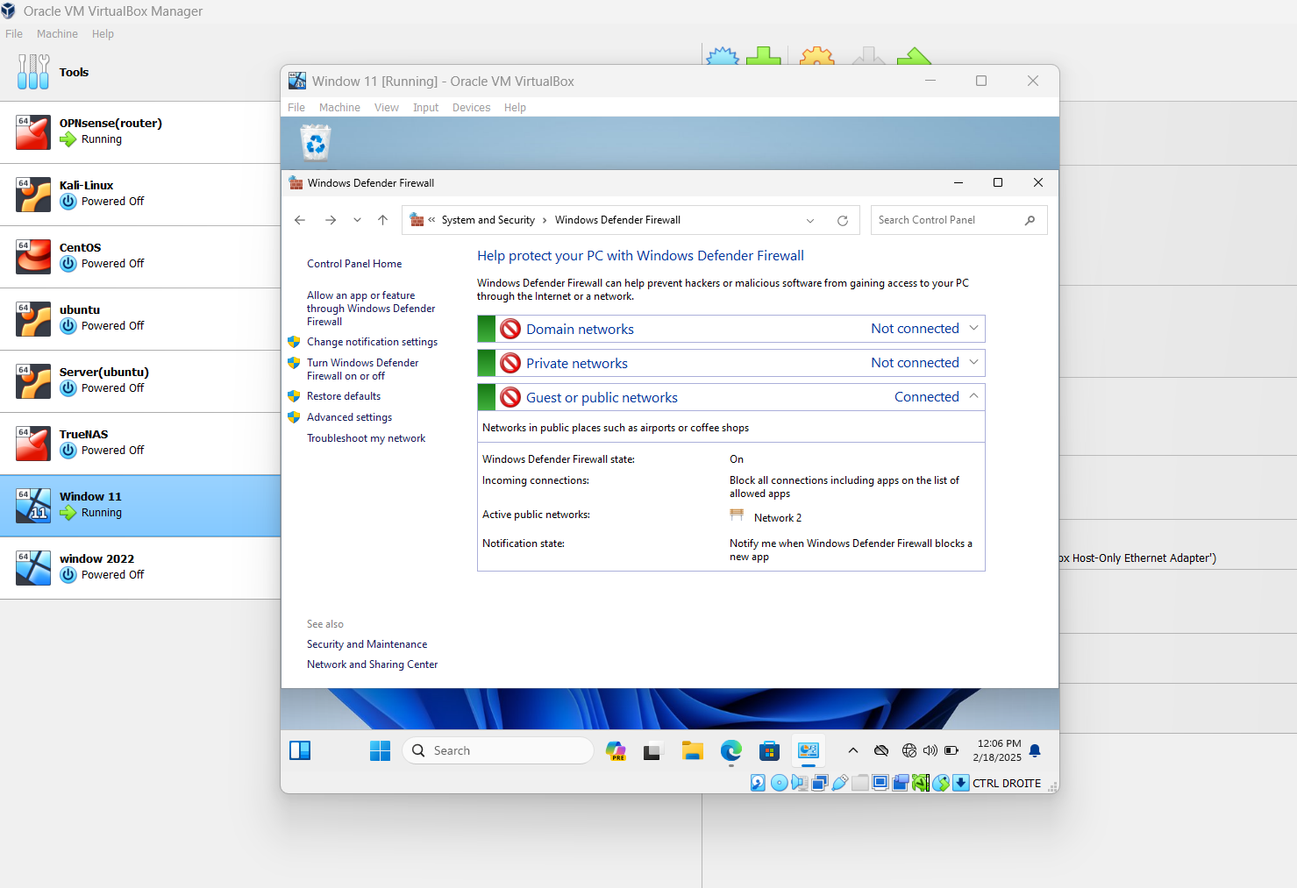

**Step 2: Add Firewall Rules  
 Block Specific Ports (Inbound & Outbound)**

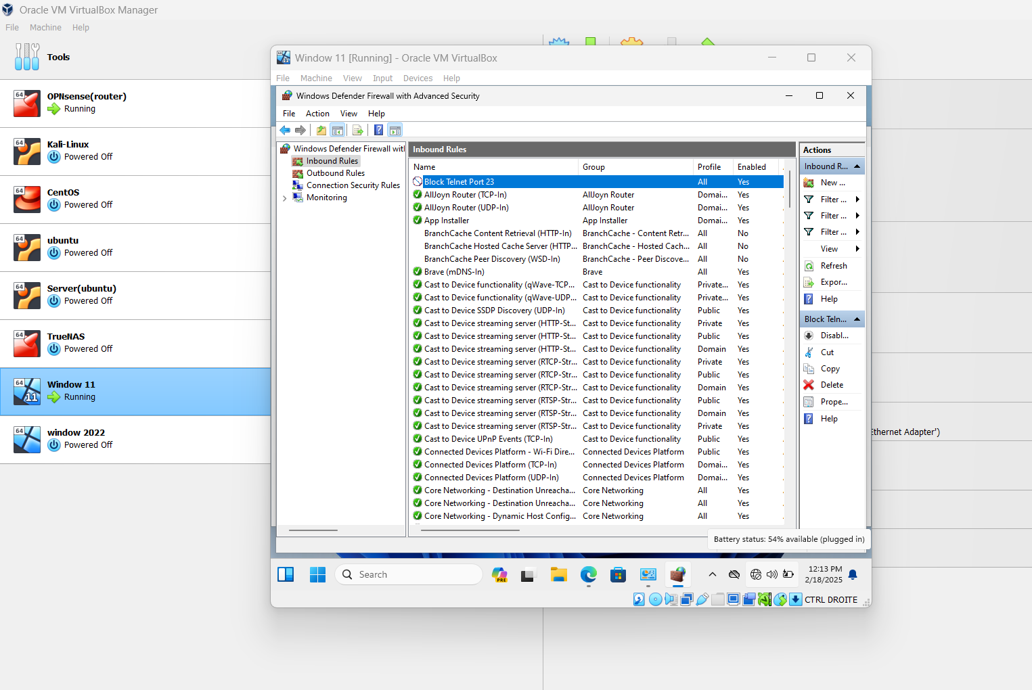

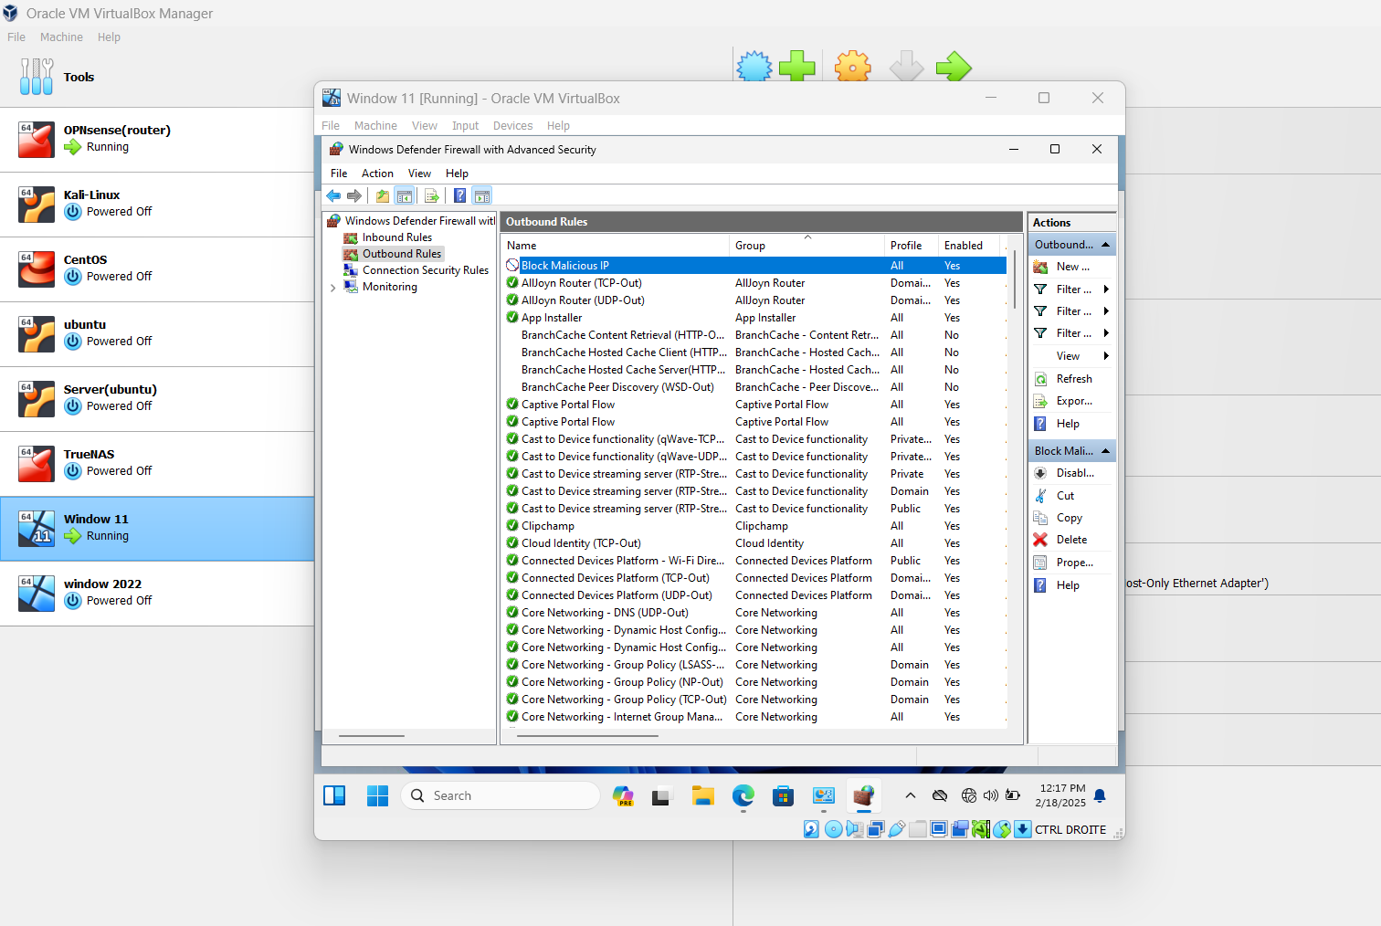

**Windows Firewall Configuration on Windows Server 2022  
 Step 1: Enable Windows Defender Firewall**

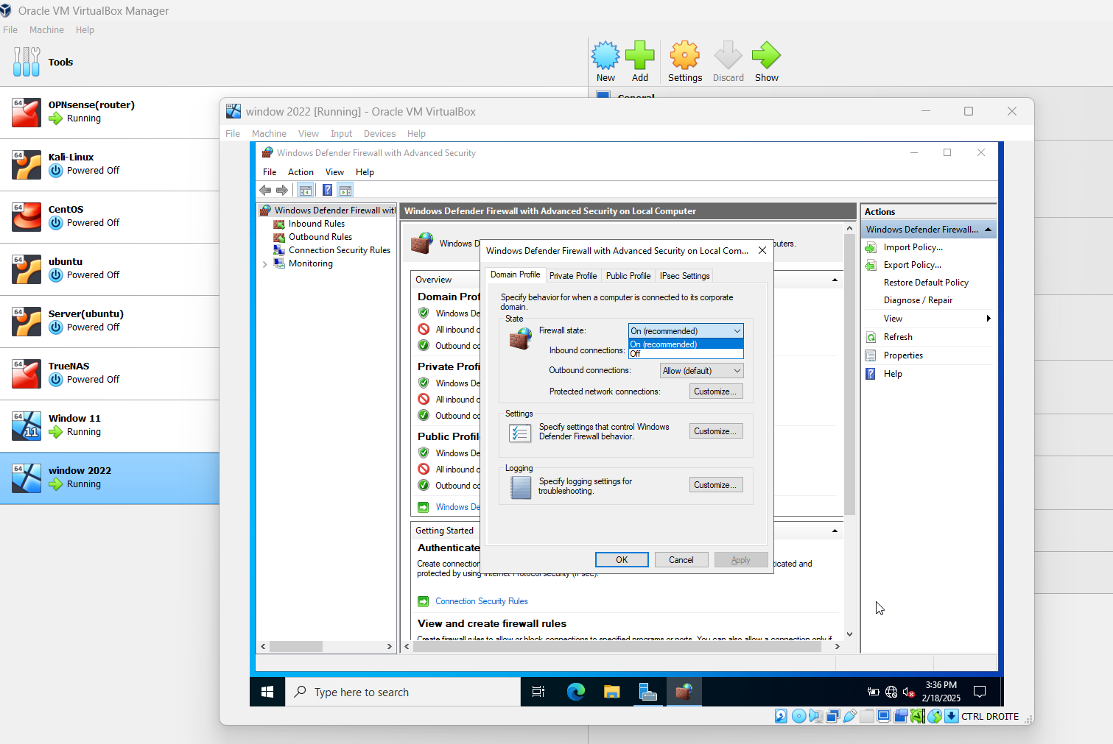

**Task 3: Host-Based Firewall with iptables on Ubuntu  
 Setup iptables on Ubuntu Desktop**

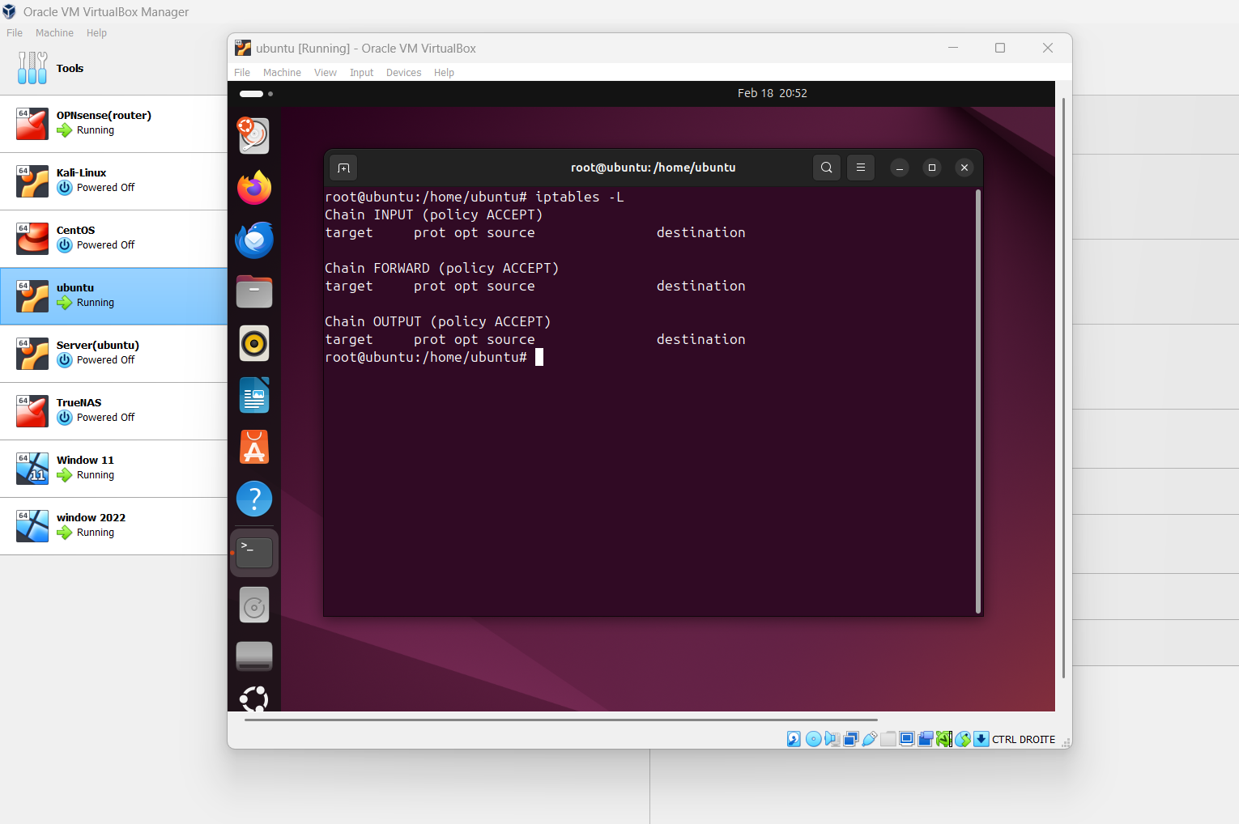

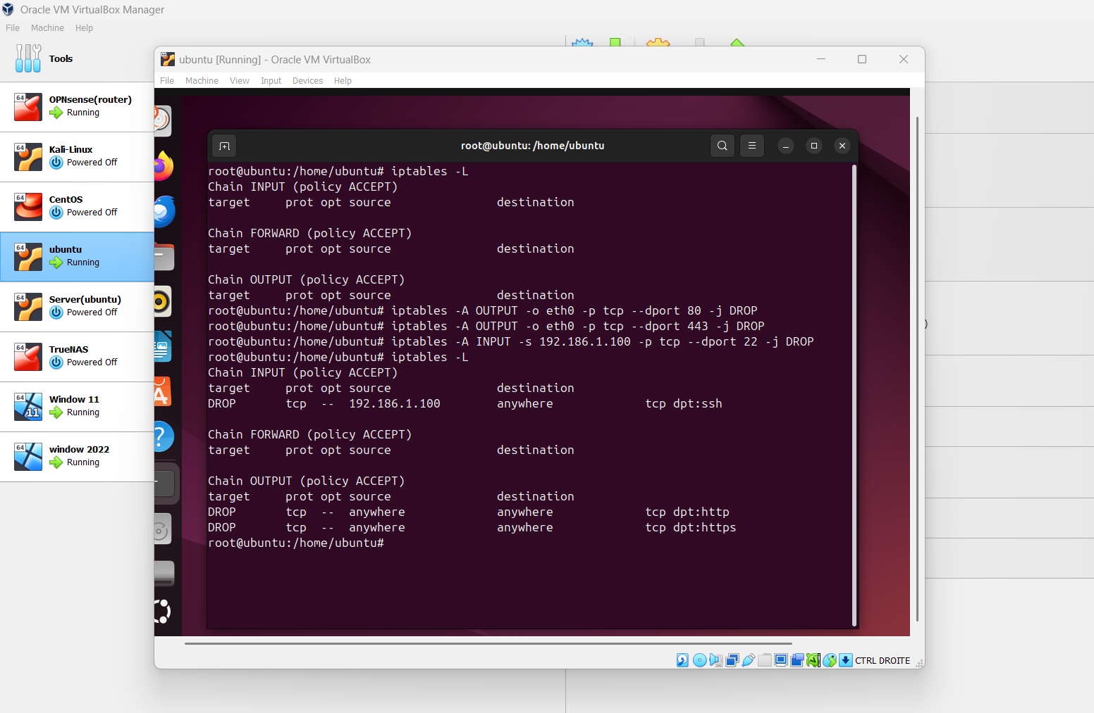

**Task 4: Network Intrusion Detection System (NIDS) with Suricata**

**Install Suricata on Ubuntu Desktop**

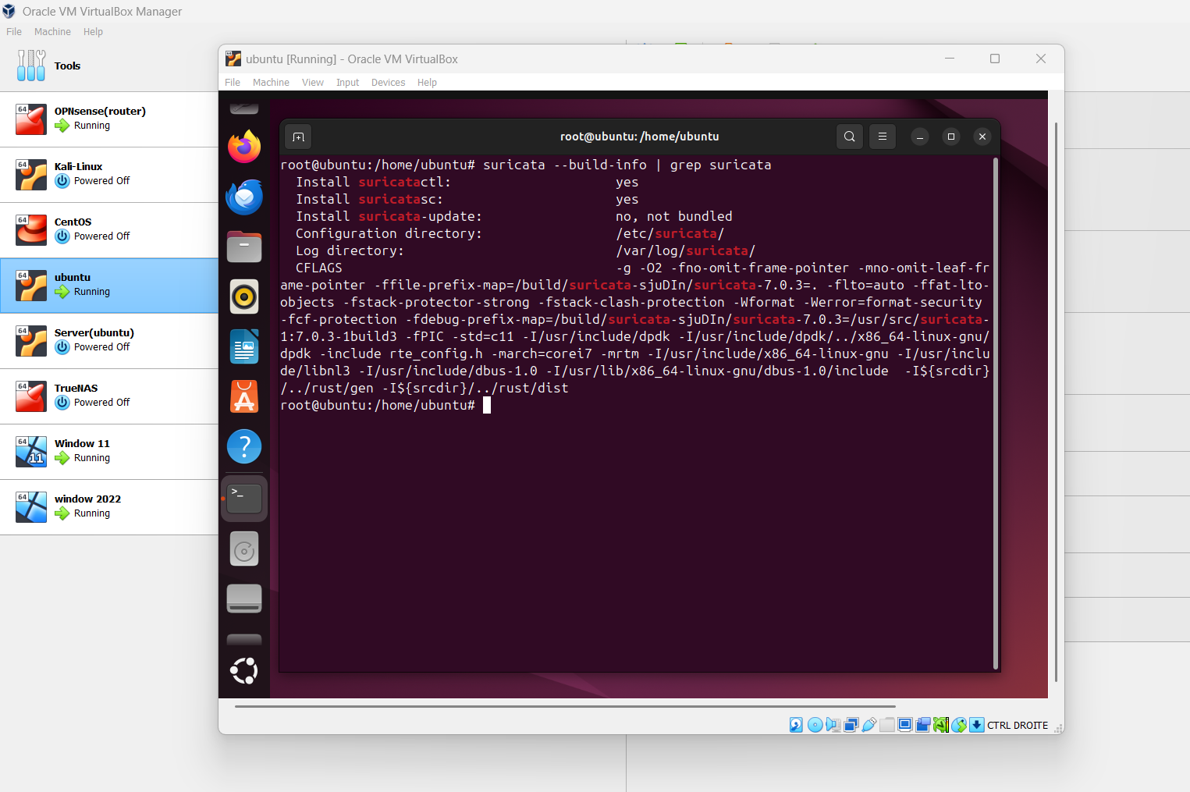

**Step 2: Configure Suricata**

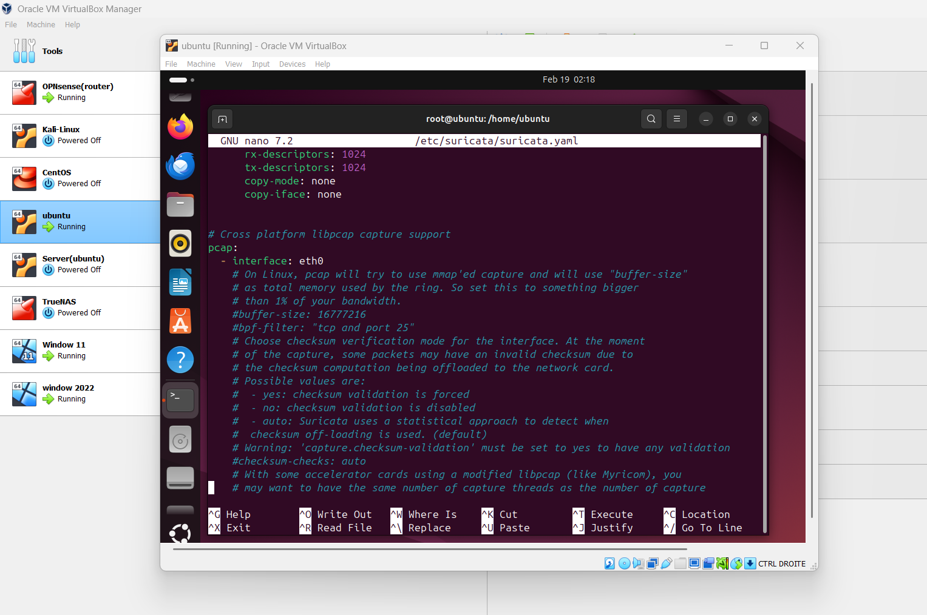

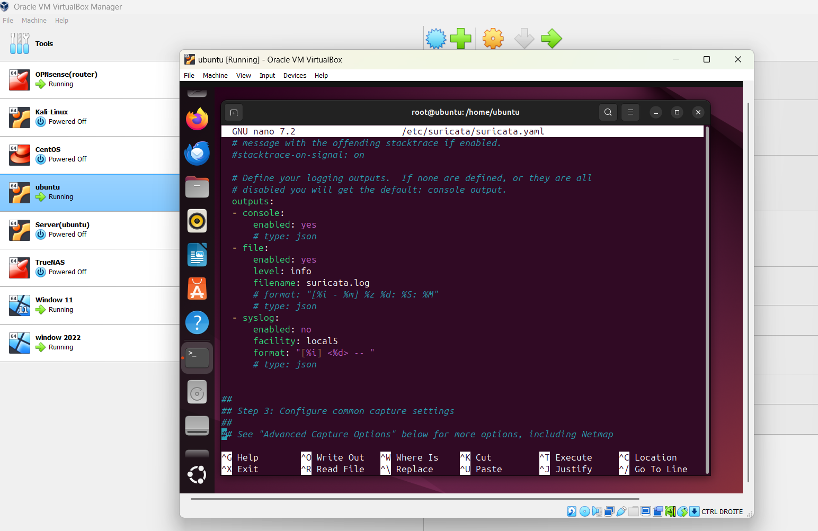

**Start Suricata with**

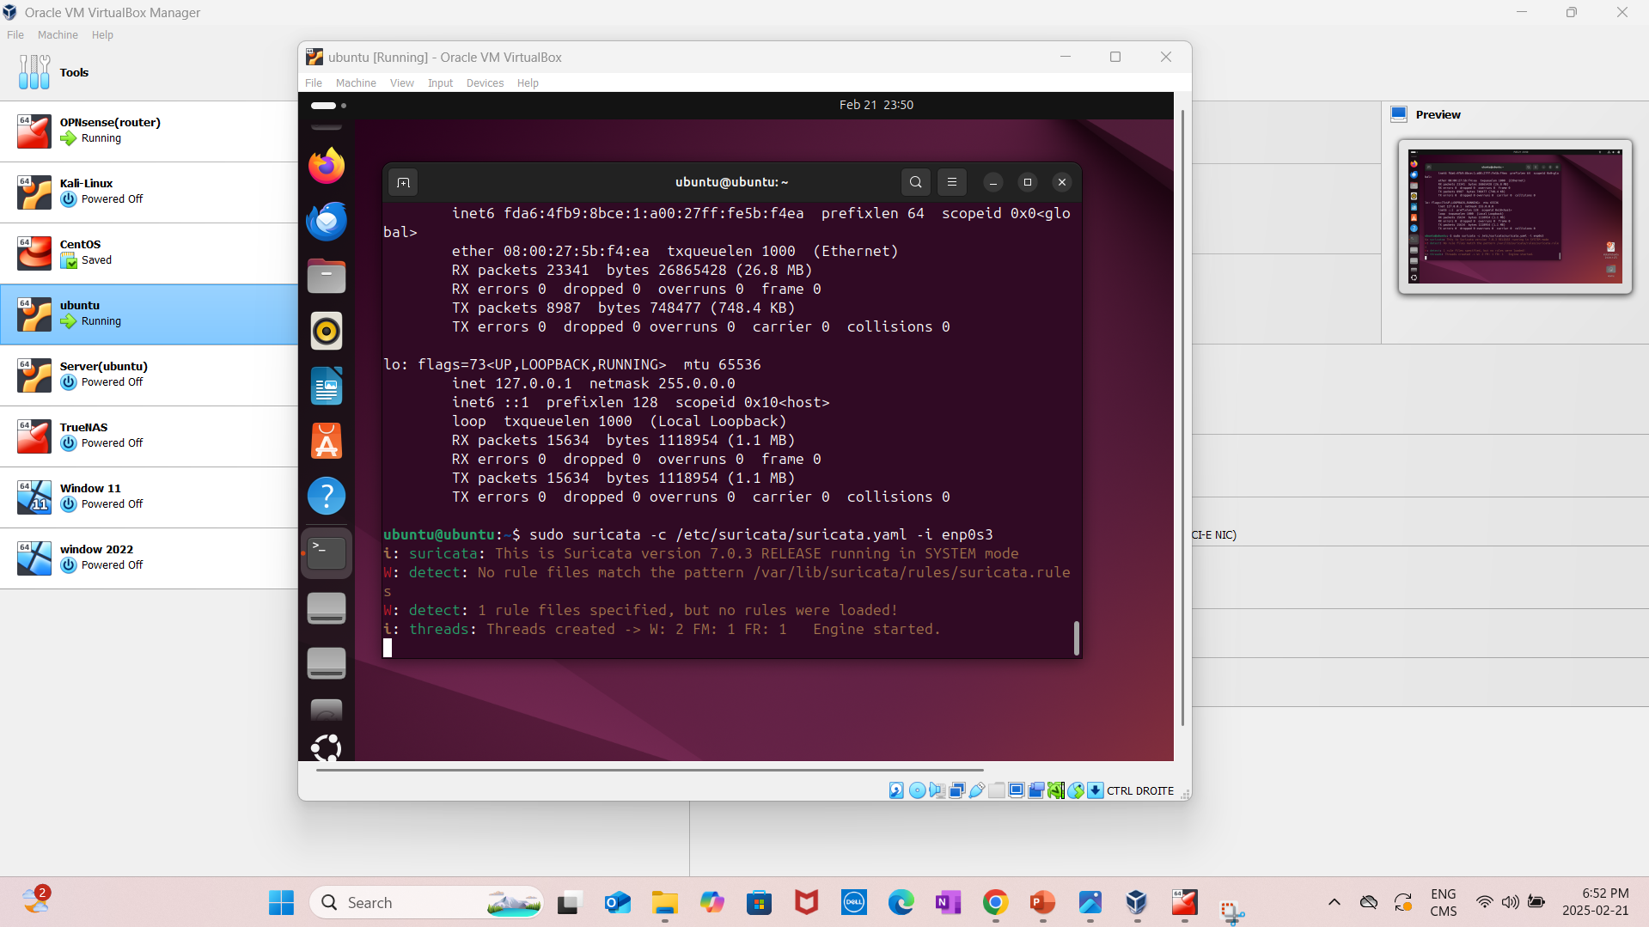

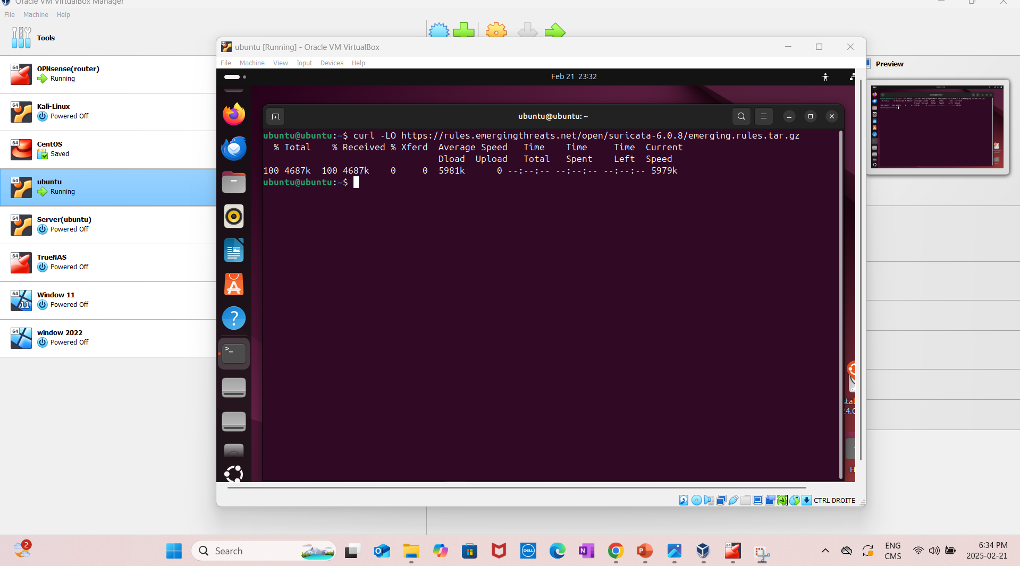

**Task 5: Host-Based Firewall with iptables on CentOS Stream 9  
 Setup iptables on CentOS Stream 9**

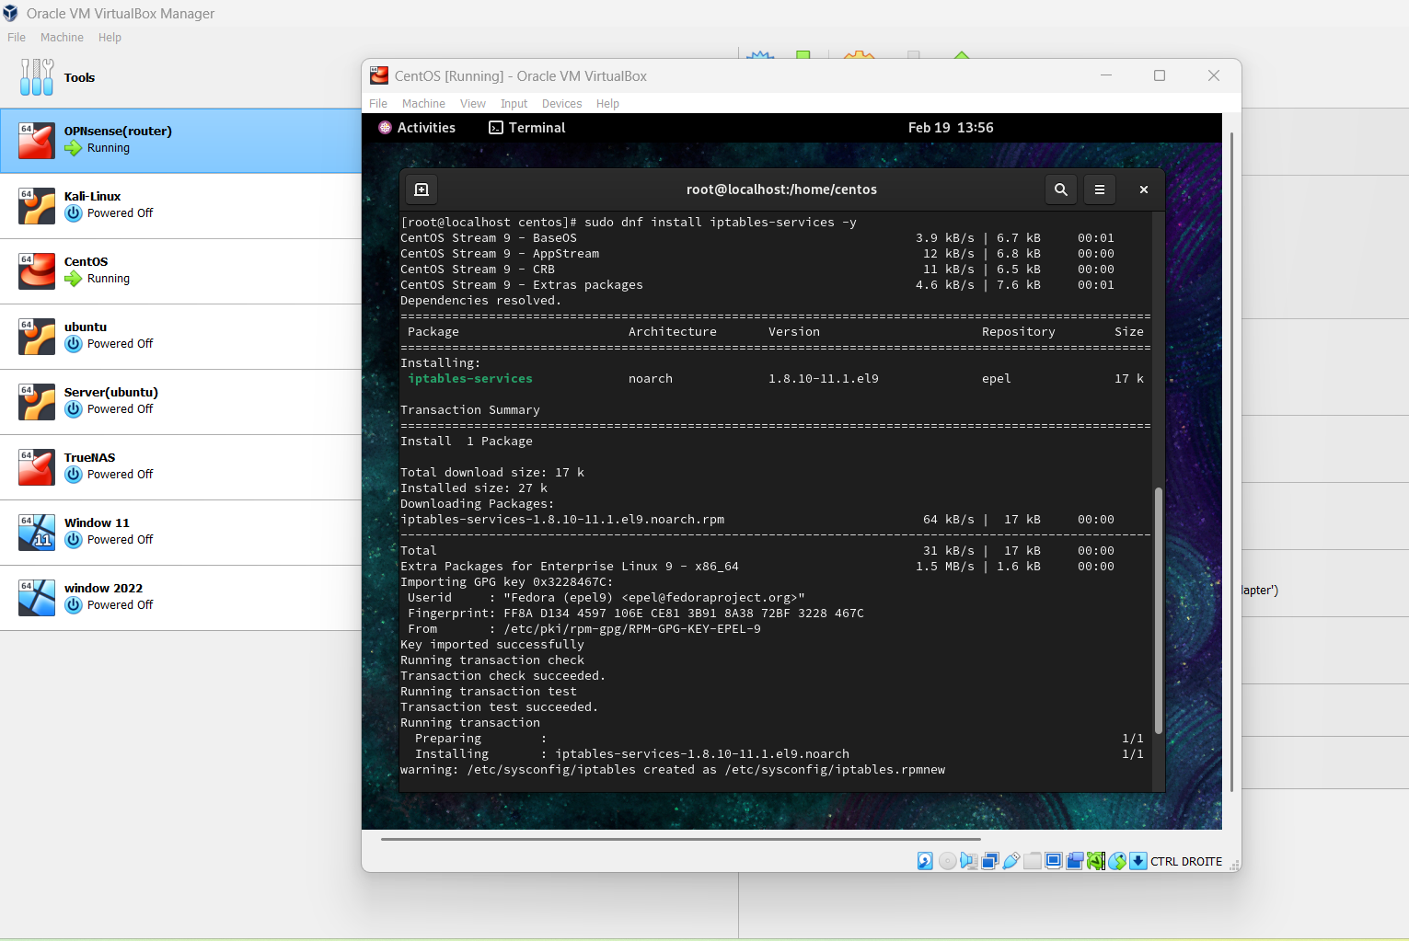

**Add rules to block specific traffic**

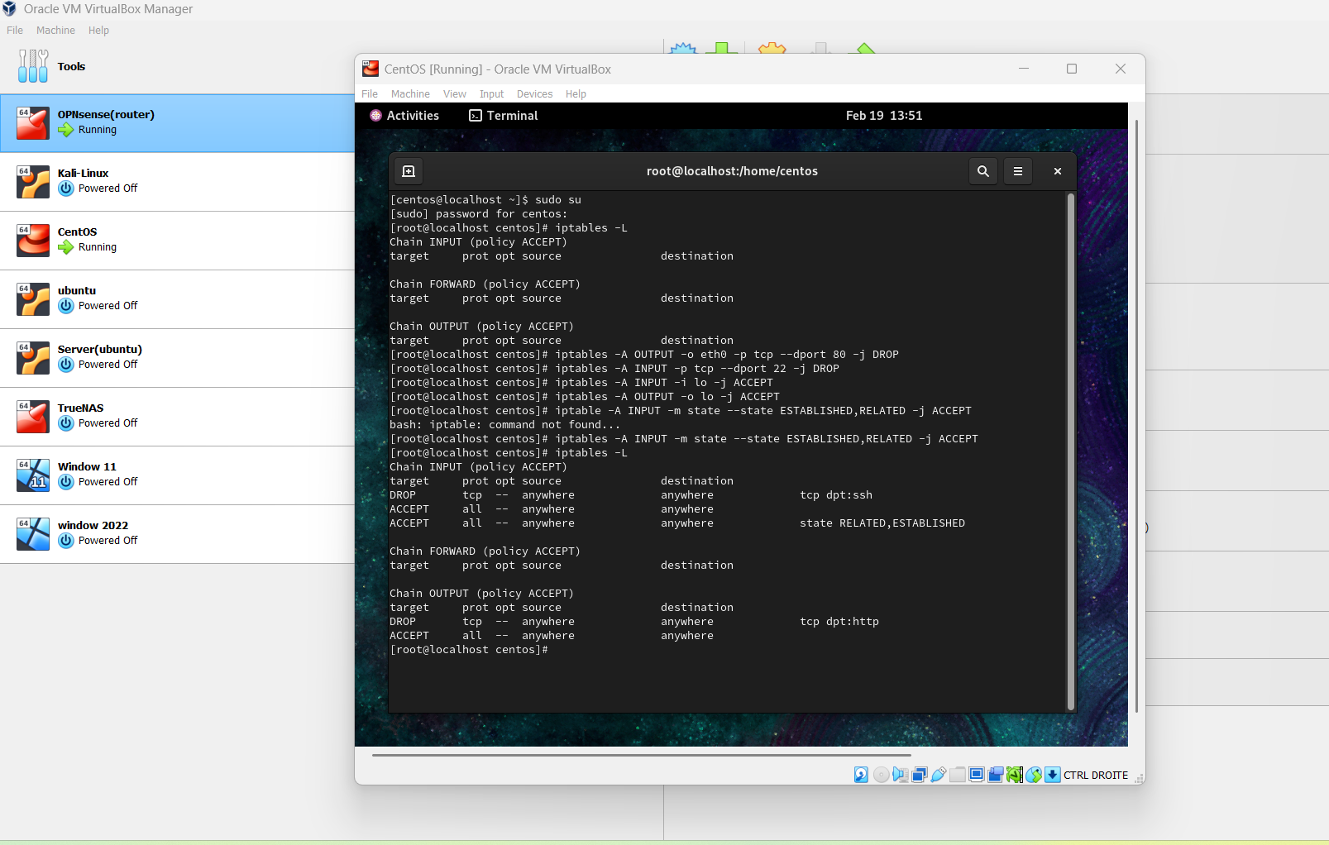

**Save the iptables rules and restart the service**

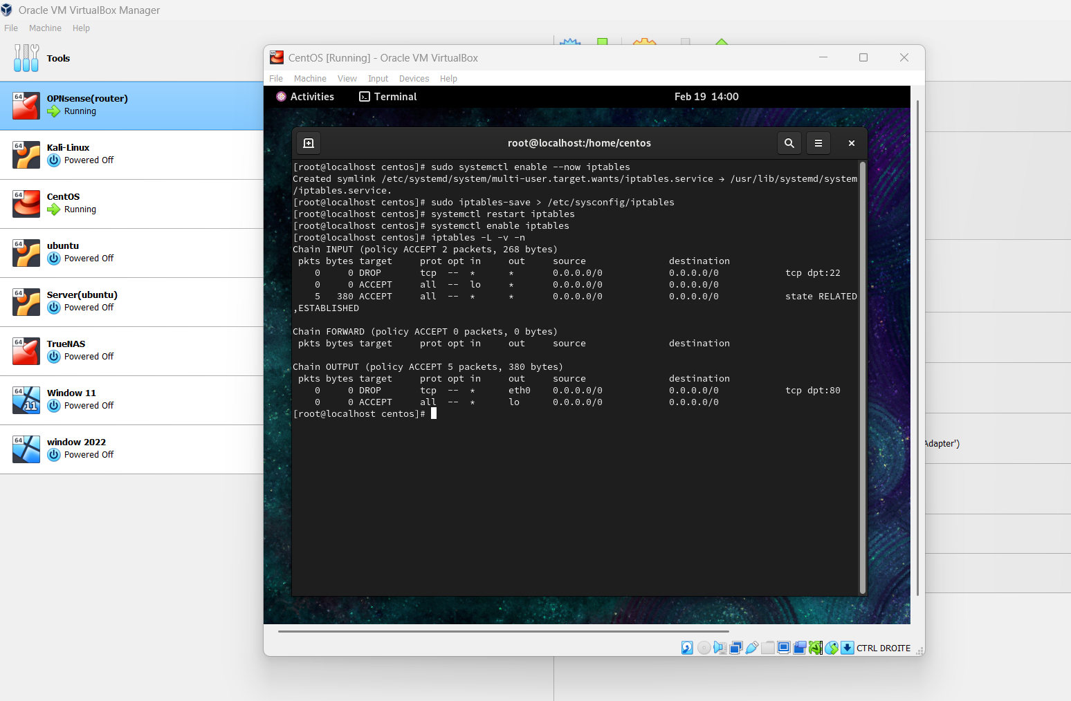

**Install and Configure Fail2ban**

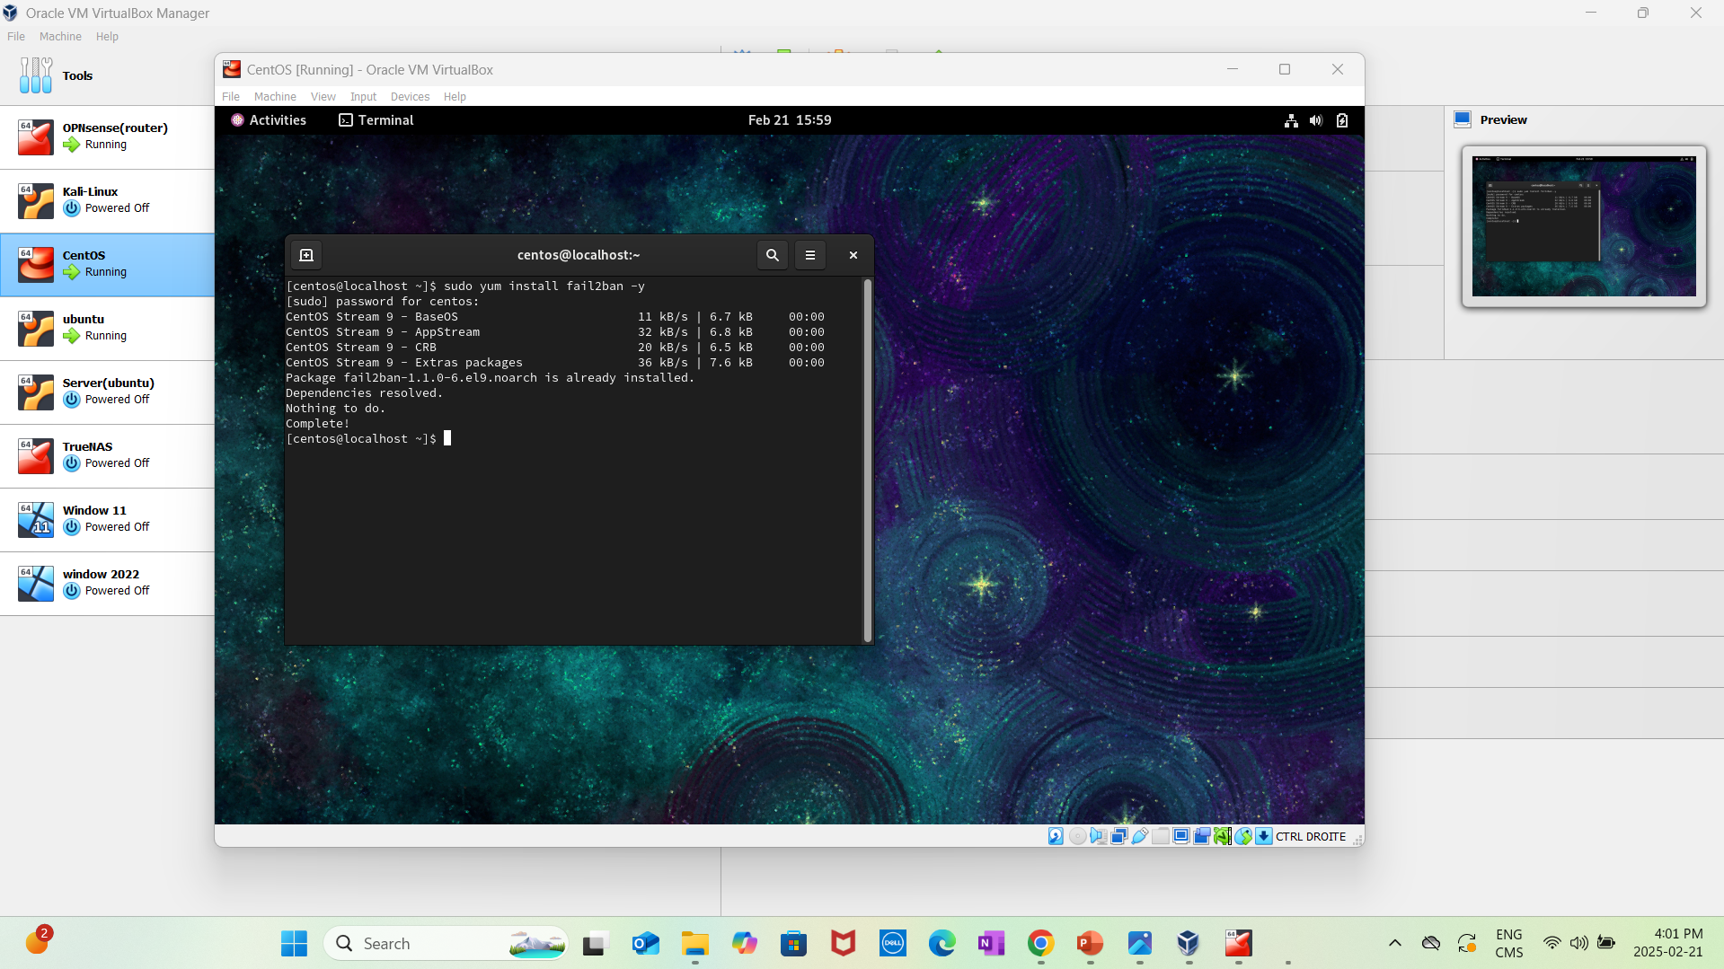

**Configure Fail2Ban**

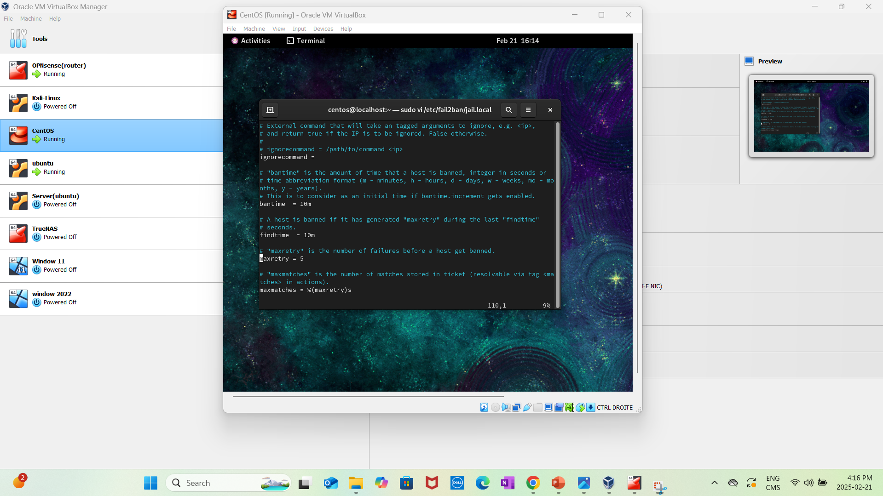

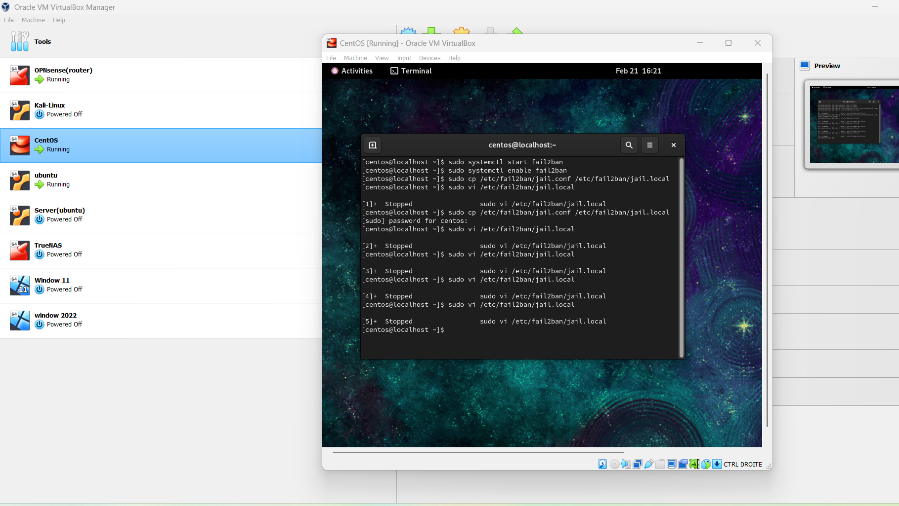

**Verifying Rules  
Test blocked traffic**

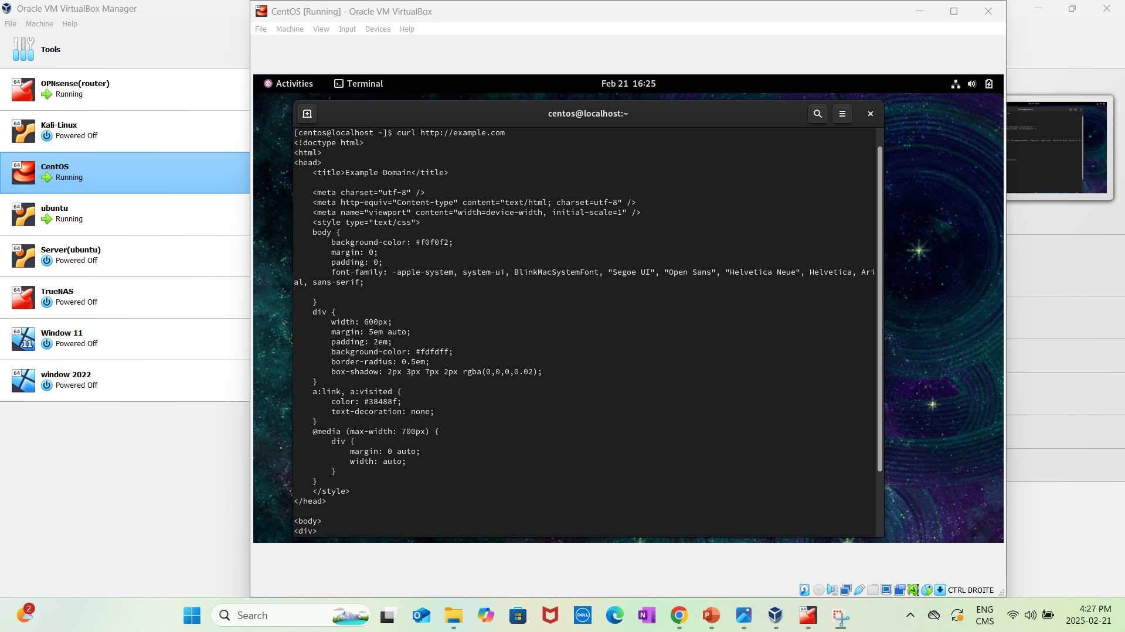

**Verify Fail2Ban logs**

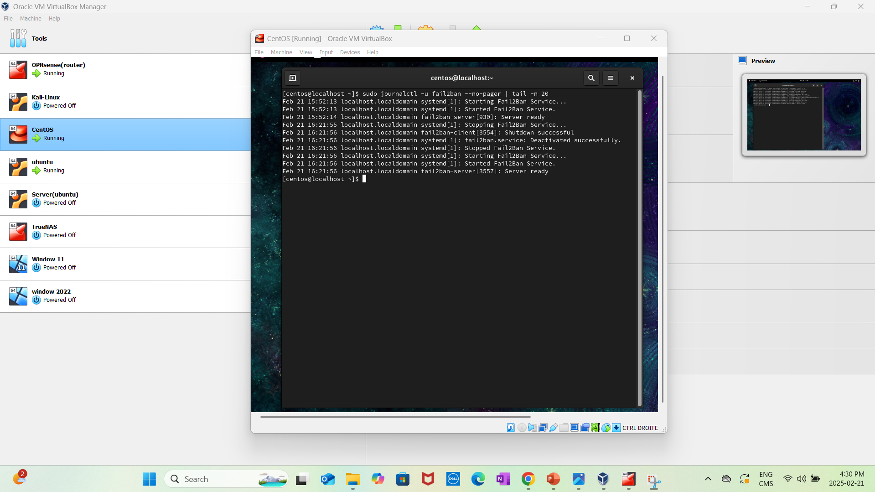

**Task 6: Host Intrusion Detection System (HIDS) with Wazuh**

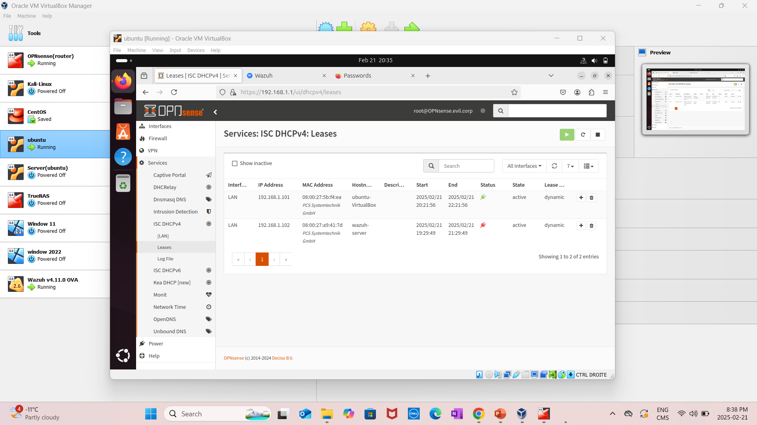

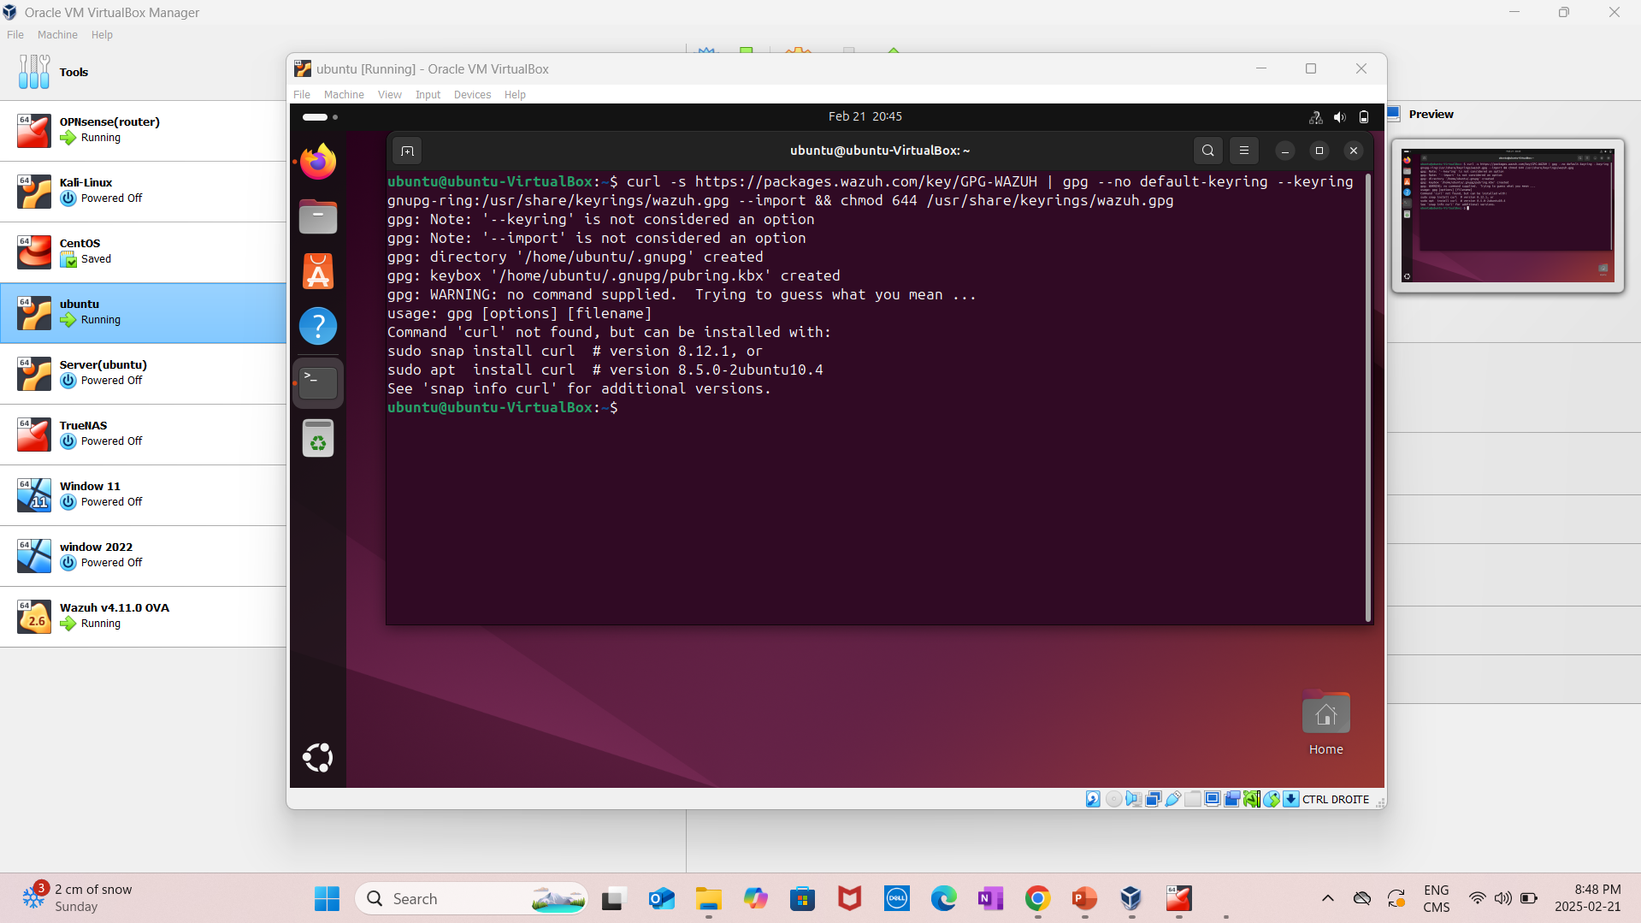

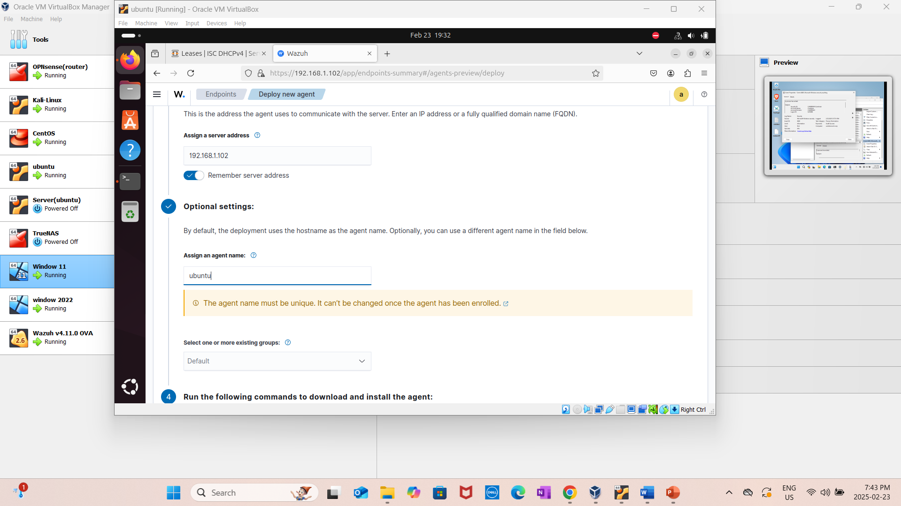

* **Descriptions of their configurations and any issues encountered.**

Alerts from legitimate SSH logins necessitated adjusting thresholds.  
The rule was modified to only activate after a greater number of unsuccessful tries.  
Excessive Use of Resources:  
  
On busy networks, Snort resulted in considerable CPU utilization.  
Solution: To lessen processing demand, logs and rulesets

* **Analysis of the logs and alerts generated during the NIDS and HIDS tests.**

1. Gathering Logs and Warnings  
Collect logs from the HIDS (including OSSEC and Wazuh) and NIDS (such as Suricata and Snort).  
For correlation, provide pertinent event, firewall, and system logs.  
Record event kinds, severity levels, triggered rules, timestamps, and source and destination IP addresses.